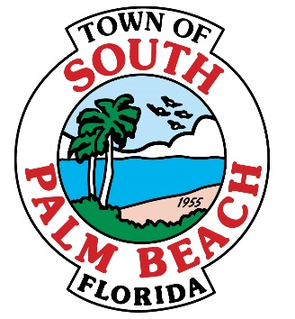

AGENDA
FIRST BUDGET PUBLIC HEARING
THURSDAY, SEPTEMBER 8, 2016– 7:00 P.M.

- CALL TO ORDER AND ROLL CALL

Mayor Bernice Fischer _____
Vice-Mayor Joseph M. Flagello _____
Council Member Stella Gaddy Jordan _____
Council Member Robert Gottlieb _____
Council Member Woodrow Gorbach _____

- PLEDGE OF ALLEGIANCE

- APPROVAL OF AGENDA

- PUBLIC HEARING: The Town of South Palm Beach will conduct the 1st First Budget Public Hearing on the proposed millage rate, and the tentative budget in the following manner:

- The Mayor will open the Public Hearing and announce that the proposed operating millage rate necessary to fund the budget is 4.3174 which is 9.63% over the rolled-back millage rate of 3.9383.
- Announce the proposed operating millage rate of 4.3174 for the General Fund.
- Summary of tentative budget
- Comments from the Public
- Public portion of the meeting is closed
- Council adoption of proposed operating millage rate of 4.3174 for Fiscal Year 2016/2017
- Council adoption of tentative budget for Fiscal Year 2016/2017
- Announce Final Budget Public Hearing – September 15, 2016 at 6:00 P.M.
- Close Public Hearing

- ADJOURNMENT

If a person decides to appeal any decision made by the council with respect to any matter considered at such meeting or hearing, he/she will need a record of the proceedings, and that for such purpose, he/she may need to ensure that a verbatim record of the proceedings is made, which record includes the testimony and evidence upon which the appeal is to be based. Persons who need an accommodation in order to participate in this meeting should contact town hall at (561) 588-8889 at least 3 business days prior to a council meeting or public hearing in order to request such assistance.

