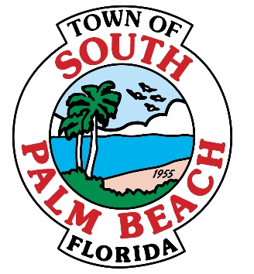

# **AGENDA**

# **REGULAR TOWN COUNCIL MEETING**

# **TUESDAY, FEBRUARY 23, 2016 AT 7:00 P.M.**

1. **CALL TO ORDER AND ROLL CALL**

**Mayor Bernice Fischer _____**

**Vice-Mayor Joseph M. Flagello _____**

**Council Member Stella Gaddy Jordan _____**

**Council Member Robert Gottlieb _____**

**Council Member Woodrow Gorbach _____**

1. **PLEDGE OF ALLEGIANCE**
2. **APPROVAL OF AGENDA**
3. **APPROVAL OF MINUTES – TAB 1**
   * Regular Town Council Meeting – January 26, 2016
4. **CORRESPONDENCE AND COMMUNICATION- TAB 2**

* Palm Beach County Fire Rescue Annual Report- October 1, 2014- September 30, 2105

1. **ORDINANCES –NONE**
2. **RESOLUTIONS- NONE**
3. **OTHER BUSINESS – TAB 3**
   * Appointments to the Board:
     + Deborah Norton- C.A.A.B. Member
     + Paul Least- Architectural Review Board- Alternate Member
     + Gary Small- Architectural Review Board- Alternate Member
4. **FINANCIALS – TAB 4**

* Un-audited Financial Statements for period ending January 2016

1. **REPORTS OF TOWN OFFICIALS – TAB 5**

* **Town Manager**
  + Report on results of workshop- Action Planning
* **Police Department**
  + Activity Report for January 2016
* **Town Attorney**
  + Discussion- Ordinance Amendments
    - Ordinance No. 284- Chapter 50, Utilities at Article II; Sewer Services.
    - Ordinance No. 285- Chapter 2, Administration at Article IV; Boards Committees, Commissions and Architectural Review Board.
    - Ordinance No. 286- Chapter 10, Buildings and Building Regulations at Article II; Permits.
* **Building Official**
  + Report on building permits issued through January 2016

1. **BOARD AND COMMITTEE REPORTS**
2. **MAYOR’S REPORT**
3. **REPORTS FROM MEMBERS OF COUNCIL**
4. **PUBLIC COMMENT**
5. **ADJOURNMENT**

**IF A PERSON DECIDES TO APPEAL ANY DECISION MADE BY THE COUNCIL WITH RESPECT TO ANY MATTER CONSIDERED AT SUCH MEETING OR HEARING, HE/SHE WILL NEED A RECORD OF THE PROCEEDINGS, AND THAT FOR SUCH PURPOSE, HE/SHE MAY NEED TO ENSURE THAT A VERBATIM RECORD OF THE PROCEEDINGS IS MADE, WHICH RECORD INCLUDES THE TESTIMONY AND EVIDENCE UPON WHICH THE APPEAL IS TO BE BASED. PERSONS WHO NEED AN ACCOMMODATION IN ORDER TO PARTICIPATE IN THIS MEETING SHOULD CONTACT TOWN HALL AT (561) 588-8889 AT LEAST 3 BUSINESS DAYS PRIOR TO A COUNCIL MEETING OR PUBLIC HEARING IN ORDER TO REQUEST SUCH ASSISTANCE.**