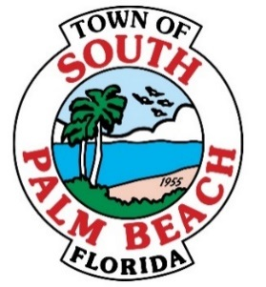

# **AGENDA**

# **REGULAR TOWN COUNCIL MEETING**

# **THURSDAY, MARCH 30, 2017 AT 4:00 P.M.**

1. **CALL TO ORDER**
2. **ROLL CALL**

**Mayor Bernice Fischer _____**

**Council Member Robert Gottlieb _____**

**Council Member Stella Jordan _____**

**Council Member Elvadianne Culbertson _____**

1. **PLEDGE OF ALLEGIANCE**
2. **APPROVAL OF AGENDA**
3. **ANNUAL ELECTION OF VICE MAYOR: PURSUANT TO TOWN CHARTER, ARTICLE TWO, SECTION 2-2, ORGANIZATION, MAYOR. AT SUBSECTION (a) AND PURSUANT TO RESOLUTION 04-2013, RULES OF PROCEDURE. AT RULE 2 (A)**
4. **DISCUSSION OF FILLING VACANCY ON TOWN COUNCIL: PURSUANT TO TOWN CHARTER, ARTICLE TWO, SECTION 2-10 FILLING OF CERTAIN VACANCIES. AT SUBSECTION (a) 3 (B)**
5. **PUBLIC COMMENT**
6. **ADJOURNMENT**

**Special Council Meeting April 4, 2017 at 7:00 P.M.**

**Next Regular Council Meeting April 25, 2017 at 7:00 P.M.**

**IF A PERSON DECIDES TO APPEAL ANY DECISION MADE BY THE COUNCIL WITH RESPECT TO ANY MATTER CONSIDERED AT SUCH MEETING OR HEARING, HE/SHE WILL NEED A RECORD OF THE PROCEEDINGS, AND THAT FOR SUCH PURPOSE, HE/SHE MAY NEED TO ENSURE THAT A VERBATIM RECORD OF THE PROCEEDINGS IS MADE, WHICH RECORD INCLUDES THE TESTIMONY AND EVIDENCE UPON WHICH THE APPEAL IS TO BE BASED. PERSONS WHO NEED AN ACCOMMODATION IN ORDER TO PARTICIPATE IN THIS MEETING SHOULD CONTACT TOWN HALL AT (561) 588-8889 AT LEAST 3 BUSINESS DAYS PRIOR TO A COUNCIL MEETING OR PUBLIC HEARING IN ORDER TO REQUEST SUCH ASSISTANCE.**